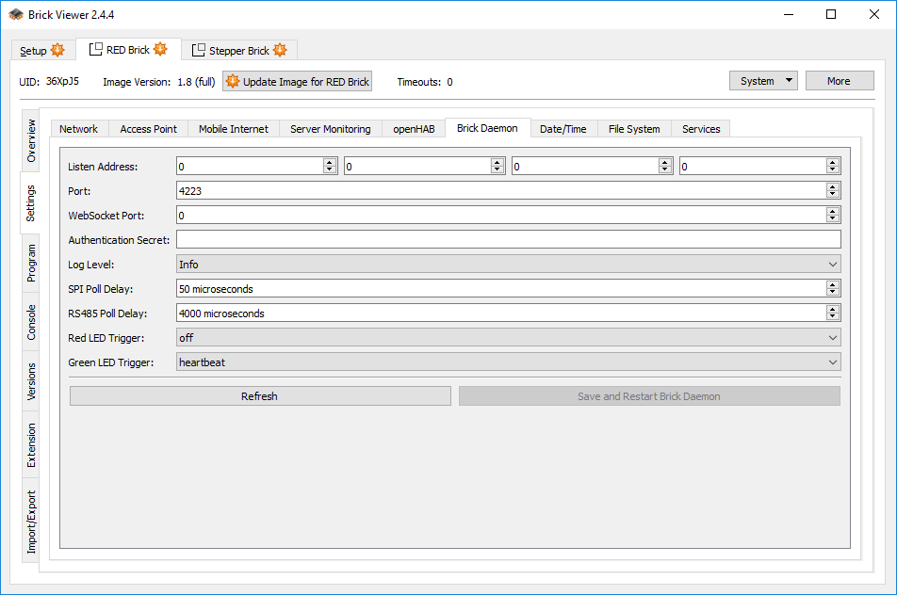

2019-07-12 12:59:05.263628 <I> <main_linux.c:281> Brick Daemon 2.2.2+redbrick started (pid: 435, daemonized: 1)
2019-07-12 12:59:07.039748 <I> <red_extension.c:524> Could not find Extension at position 0
2019-07-12 12:59:07.040243 <I> <red_extension.c:524> Could not find Extension at position 1
2019-07-12 12:59:07.053146 <I> <redapid.c:309> Connected to RED Brick API Daemon
2019-07-12 12:59:07.668129 <I> <red_stack.c:531> SPI stack slave discovery done. Found 1 slave(s) with 1 UID(s) in total
2019-07-12 13:07:05.490192 <I> <main_linux.c:281> Brick Daemon 2.2.2+redbrick started (pid: 418, daemonized: 1)
2019-07-12 13:07:07.279586 <I> <red_extension.c:524> Could not find Extension at position 0
2019-07-12 13:07:07.280076 <I> <red_extension.c:524> Could not find Extension at position 1
2019-07-12 13:07:07.284614 <I> <redapid.c:309> Connected to RED Brick API Daemon
2019-07-12 13:07:07.894855 <I> <red_stack.c:531> SPI stack slave discovery done. Found 1 slave(s) with 1 UID(s) in total
2019-07-12 20:07:17.949906 <I> <network.c:373> Added new client (N: g_red_brick, T: file, H: 23, A: disabled)
2019-07-12 20:07:17.950075 <I> <red_usb_gadget.c:115> Connected to RED Brick USB gadget

